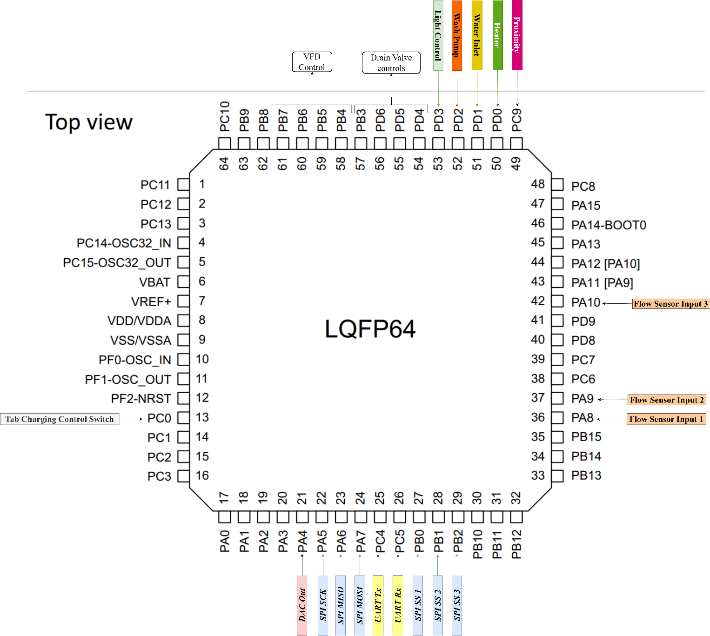

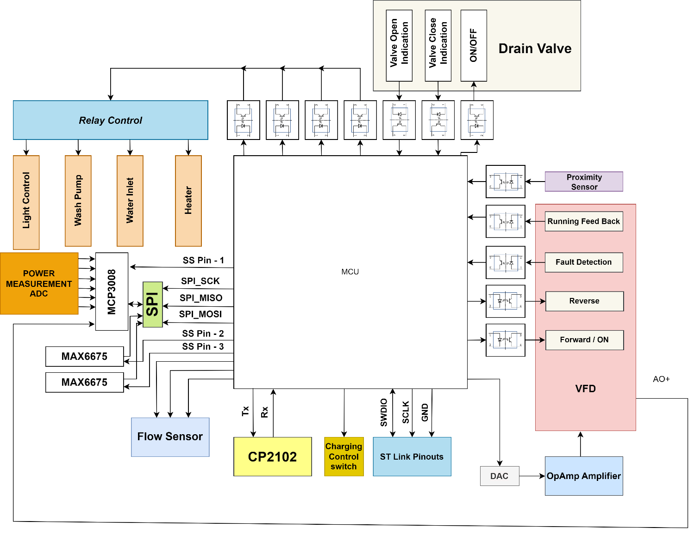

|  |  |  |
| --- | --- | --- |
| PIN | PIN Description | I/O Type |
| **SPI** | | |
| PA5 | SPI_SCK | Output |
| PA6 | SPI_MISO | Input |
| PA7 | SPI_MOSI | Output |
| PB0 | SPI_SS 1 | Output |
| PB1 | SPI_SS 2 | Output |
| PB2 | SPI_SS 3 | Output |
| **Flow Sensor** | | |
| PA8 | Sensor 1 | Input |
| PA9 | Sensor 2 | Input |
| PA10 | Sensor 3 | Input |
|  |  |  |
| **Drain Valve** | | |
| PD4 | To indicate the Valve is Open | Input (OptoCoupler) |
| PD5 | To indicate the Valve is Closed | Input(OptoCoupler) |
| PD6 | ON / OFF Control | Output(OptoCoupler) |
| PB3 | Need to verify is required For Reverse operation | Output(OptoCoupler) |
|  |  |  |
| **VFD** | | |
| PB4 | Forward/ON control | Output(OptoCoupler) |
| PB5 | Reverse | Output(OptoCoupler) |
| PB6 | Motor Running Feed Back | Input(OptoCoupler) |
| PB7 | Fault Detection | Input(OptoCoupler) |
|  |  |  |
| PC9 | Proximity Sensor | Input(OptoCoupler) |
|  |  |  |
| **Relay Module** | | |
| PD0 | Heater | Output (OptoCoupler) |
| PD1 | Water Inlet | Output (OptoCoupler) |
| PD2 | Wash Pump | Output (OptoCoupler) |
| PD3 | Light Control | Output (OptoCoupler) |
|  |  |  |
| **TAB Charging Switch GPIO** | | |
| PC0 | Transistor Switch Control GPIO | Output |
| **UART** | | |
| PC4 | Uart Transmitter (Tx) | Output |
| PC5 | Uart Receiver (Rx) | Input |
|  |  |  |
| **ST LINK Debugger** | | |
| PA14 | SWDIO | I/O |
| PA13 | SCLK | Output |
|  | GND |  |
|  |  |  |